Vonderhaar Fireplace, Stoves & Masonry
9348 Cincinnati Columbus Road
Cincinnati, OH 45241
513-242-1110/513-777-0211 fax
www.vonderhaar.com

Fireplace Measurement Form
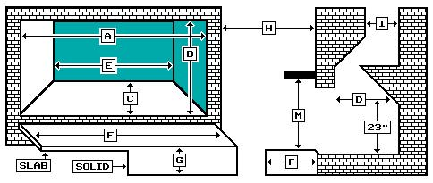
- Width at front _________
- Height at front _________
- Depth __________
- Depth at 23” above hearth _________
- Width at backwall _________
- Hearth width ______ depth ________
- Hearth raised ______ “ from floor (check one) Slab ___ Solid ___
- Facia material ___________ (brick, stone, etc)
- Flue opening ___________
- Chimney height _________
M. Combustible mantel (y/n) _____ Distance above hearth ______ / mantel width____ depth_____
Fireplace has outside air (y/n) ____
Ash dump (y/n) )_____
Is chimney on an outside wall (y/n) _____
Size of house _________ square feet
Insulation: good __ medium__ poor__

